Exploring Relationships between Cultural Dimensions, Economic Development, and Education

Andrew McCartney

University of Virginia

Beginning in the 1966, Dutch psychologist Geert Hofstede (Hofstede, 1983) undertook a project to quantify cultural dimensions as a way of quantifying what he described as cultural responses to problems that face any society. In part, he undertook the research to solve problems related to globalization in industrial-organizational psychology, i.e., how can a firm with locations across the globe become more efficient and minimize cross cultural misunderstandings? His original data set utilized 116,000 questionnaires to individuals in roughly 60 countries (the process was iterative and at times he reports between 50 and 67 countries). These countries themselves provide the unit of analysis, as the questionnaire he developed is not intended to be a personality test of an individual but rather a glimpse of a culture.

Using confirmatory factor analysis, four (then later six; Hofstede & Minkov, 2013) factors were determined: power distance, which describes the degree to which control and decision making are structured hierarchically; uncertainty avoidance, the degree to which ambiguity makes individuals uncomfortable; individualism versus collectivism, describing the relative importance of personal or individual factors within a culture; and masculinity, the degree to which gender roles differ or responses to certain survey questions differed on gender. The two additional factors were long-term versus short-term orientation and indulgence vs. restraint, both names of which describe well the intended phenomena. His factors were confirmed within the original data set, and then again via additional survey research (Hofstede & Bond, 1984).

Because some previous research had found relationships between these cultural dimensions and education policy around the world (see Cheung & Chan, 2008), a dataset was created which enabled comparisons between these dimensions and data available from the United Nations related to economic growth and Human Development as well as data pertaining to the monitoring of the education goals within the Millennium Development Goals (see World Health Organization, n.d.) and the Sustainable Development Goals (See United Nations, n.d.).

First, the cultural dimensions themselves were examined to understand their distributions and interactions (see Appendices A and B). Additionally, a correlation matrix was run to determine the degree to which the six factors were interconnected (See Appendix C). This table shows that for the most part, correlations between the factors are low, indicating that they are indeed distinct; however, the correlation between power distance and individualism is -0.63, which is remarkably high if not surprising. The interpretation is that in a culture that values individual contributions, hierarchical structures will be much less likely to exert control. Additionally, there is a similar if less strong relationship between Long-Term Orientation and Indulgence, where they are correlated at -0.46, meaning that cultures that are more long-term oriented are more likely to show restraint rather than to indulge themselves. Again, this negative correlation is unsurprising, but both of these show that some caution must be taken in in interpreting results of analyses and in the reification of the cultural dimensions in a larger sense.

Having gained some insight into the dimensions themselves, the first question is whether they have predictive power for an important variable for international work; in this case, I chose the Inequality Adjusted Human Development Index, using a multiple linear regression with each of the six dimensions as a predictor variable. Results of this regression are in Appendix D. Because of the simultaneous six comparisons, a Bonferroni correction was used which generated a new alpha level of 0.0083. Individualism, Indulgence vs Restraint, and Long-Term Orientation met this threshold for significance; uncertainty avoidance was t = 2.66 (p = 0.011) which is both close to the selected significance level and well below the typical level of alpha = 0.05. More research may be needed to see with certainty whether this is indeed a strong predictor or a statistical aberration. However, it must be noted that despite the small number of available observations (N = 56 countries), significance was achieved with vanishingly small practical effect sizes, the largest of which represents a 0.3% change in Human Development (this being individualism).

Next, I undertook to see if particular dimensions might predict data found in the MDG and SDG data sets; however, before doing this I wanted to visualize what kind of progress is being made yearly in at least one particular goal. For this, I chose girls’ primary enrollment in a selection of African nations to visualize the level of improvement, over time. This visualization is within Appendix E. The reader may note several things: first that missing data are common; in fact, many countries such as Somalia were eliminated from this chart because data were missing entirely. Secondly, one may note that for some countries, growth in girls’ primary school participation increases steadily (e.g. in Benin, Chad, Gambia, and Tunisia) whereas in other countries, growth is marked by inconsistencies, such as Zambia, which experienced a giant leap between 2000 and 2005 and Lesotho, which had a severe drop in the late 90s before a return to normalcy. Finally, the case of Liberia illustrates the need for caution in these interpretations. Their rates are highest before the war in the late 1990s and then drop, but show an *upward* trend until the time of the Ebola Virus Disease outbreak until 2014: the regression model treats this as a downward trend overall, but in truth there are three separate trends at work that are captured as one in a remarkably small data set.

What educational factors can be well-predicted by the cultural dimensions? First, I took the perhaps more obvious route and sought to see if the Masculinity dimension well predicts school participation or outcomes for girls; in general, this was not the case, with most countries with low girls’ education clustering near the mean of masculinity and providing no clear trend. However, one available variable, “Participation rate of girls and women in formal and non-formal education within the last 12 months” did exhibit a relationship with masculinity (Appendix F), including a regression which indicated that roughly 10% of the variance between countries in women’s participation in education could be explained by variation in masculinity between nations, with more masculine nations exhibiting slightly lower participation in women’s education.

Next, I was intrigued by the apparent theoretical relationship between power-distance and economic inequality. Both of these describe *kinds* of inequality, where power distance describes inequality in hierarchical systems or organizational structures and economic inequality describes, of course, disparities in wage or wealth. Because the HDI in use in this data set is inequality adjusted, does any relationship remain to the kind of inequality described by the PDI? In fact, this is the case (Appendix G). where Power Distance is in fact a significant predictor of the Inequality Adjusted income index, though again the practical significance is lower, the variance explained is nearly 28%.[1] This indicates that perhaps there are two separate sources of inequality, one of which is structural (i.e., income and wealth) and one of which is cultural (power distance) and the interactions between these may be mediated or moderated by additional variables. Again, further research may be required.

Next, I sought to determine if the allocation of school materials can be predicted by long-term orientation, with the idea being the investments in things such as computer technology might be an expression of a long-term investment and commitment to education. Computer use in classrooms was given at three levels (primary, lower secondary, upper secondary) so these were averaged to create a single outcome variable for a regression model (see Appendix H). Though the visual data for these (Appendix I) are suggestive of a relationship, the number of countries reporting on computer use (roughly 20) is too small to allow for appropriate standard errors to confirm this hypothesis, which was first tried with just long-term orientation then all six of the cultural dimensions.

Finally, we have two indicators for economic parity in educational outcomes, where one tests parity for numeracy and the second for literacy by comparing a lower quartile’s scores with an upper quartile’s scores. I tested both of these against the previous relationship I found between power distance and inequality-adjusted income (see Appendix J). These two regressions indicated that there may be a relationship between IA-income; and economic parity in literacy, but given the number of hypotheses I’ve already tested within this dataset, I’m willing to brush that off as a potential type I error, particularly because this result did not hold for numeracy, which highly correlated with literacy (r = 0.93).

In some, what can be learned from exploring these data sets? First, that the incomplete nature of the data of economic development and education development is a problem that is both historical and ongoing; many of these analyses contained herein would have been more robust had more data been available, particularly from countries which may tell us something about the differences between “main sequence” development countries and “failed states” such as Somalia. Additionally, I have tried to indicate that a large degree of caution must be taking when ‘fishing’ for findings such as these; though the questions I asked and answers I sought were based on logical relationships between the available constructs, testing so many hypotheses together vastly increase the risk of type I error and I have tried to account for this wherever possible, going so far as to dismiss a significant result on the grounds that it seemed inconsistent with a true trend. So-called “fishing expeditions” are maligned within the sciences for good reason, and therefore we must be sure to have the appropriate statistical understanding within one’s tacklebox. Finally, it seems that the cultural dimensions may indeed offer some insight into how outcomes, broadly defined, are determined for countries; however, causal interpretation must be very limited. For example, in the case of income and power distance, it could very well be the case that countries with high rates of income are less driven to hierarchical structures; this is to say, the causal relationship could go either way for any of these relationships and omitted variables are potentially infinite when discussing things as complex as culture, international development, and education.

References

Cheung, H. Y., & Chan, A. W. (2008). Relationships amongst cultural dimensions, educational expenditure and class size of different nations. *International Journal of Educational Development*, *28*(6), 698-707.

Hofstede, G. (1983). National cultures in four dimensions: A research-based theory of cultural differences among nations. *International Studies of Management & Organization*, *13*(1-2), 46-74.

Hofstede, G., & Bond, M. H. (1984). Hofstede's culture dimensions: An independent validation using Rokeach's value survey. *Journal of cross-cultural psychology*, *15*(4), 417-433.

Hofstede, G., & Minkov, M. (2013). VSM 2013. *Values survey module*.

United Nations. (n.d.). *Sustainable Development Goals.* retrieved from http://www.un.org/sustainabledevelopment/sustainable-development-goals/

World Health Organization. (n.d.). *Millennium Development Goals (MDGs).* Retrieved from http://www.who.int/topics/millennium_development_goals/about/en/

Appendix A

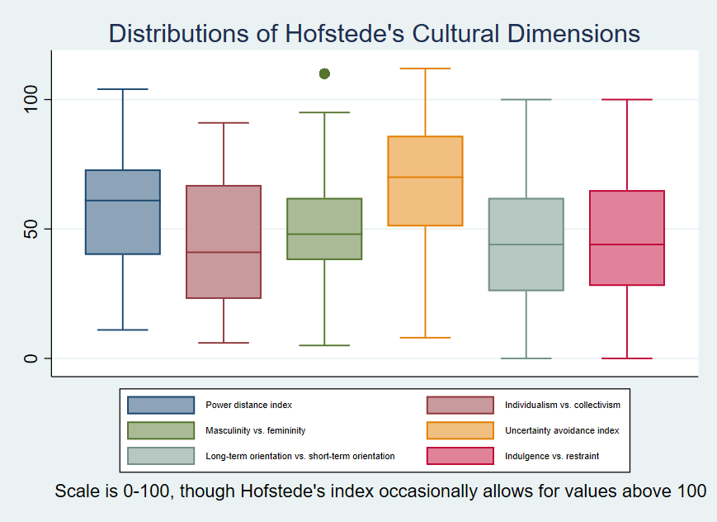

Appendix B

|  |  |
| --- | --- |
| Variable | Mean (SD) |
| Power distance index | 59.1471  (22.0232) |
| Individualism vs. collectivism | 44.1176  (23.9636) |
| Masculinity vs. femininity | 48.7794  (19.9767) |
| Uncertainty avoidance index | 67.7647  (23.8847) |
| Long-term orientation vs. short-term orientation | 45.1778  (23.6954) |
| Indulgence vs. restraint | 45.3736  (22.5609) |

Appendix C

Correlations between individual Cultural Dimensions



Appendix D

|  |  |
| --- | --- |
|  | Human Development in 2014 |
| Power Distance | -0.001 |
|  | (0.001) |
| Individualism | 0.003 |
|  | (0.001)* |
| Masculinity | -0.001 |
|  | (0.001) |
| Uncertainty Avoidance | 0.001 |
|  | (0.001) |
| Long Term Orientation | 0.002 |
|  | (0.001)* |
| Indulgence vs. Restraint | 0.002 |
|  | (0.001)* |
| _cons | 0.344 |
|  | (0.087)* |
| *R*2 | 0.69 |
| *N* | 56 |

Appendix E

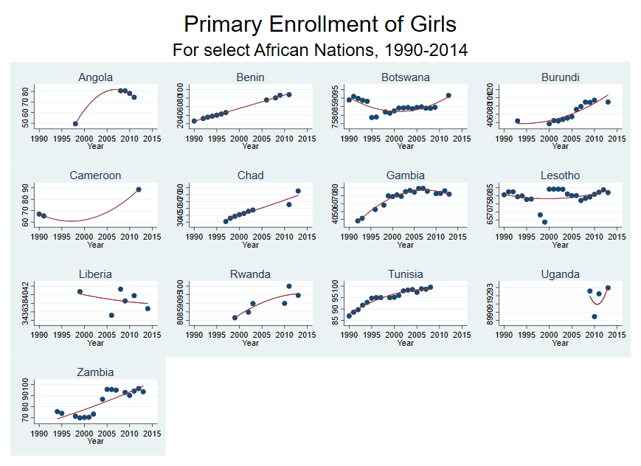

Appendix F

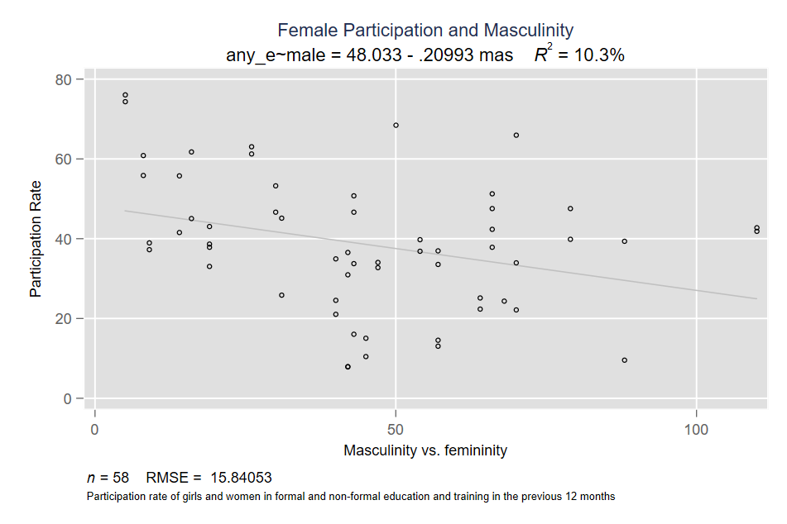

Appendix G

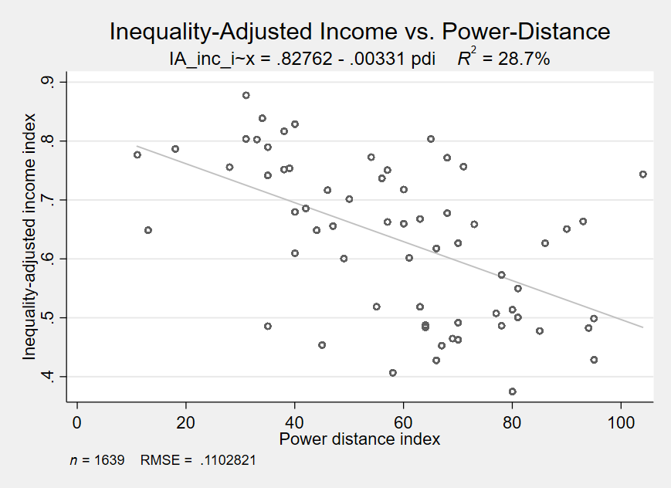

Appendix H

|  |  |  |
| --- | --- | --- |
|  | computers | computers |
| Long term orientation | 0.40 | 0.21 |
|  | (0.20) | (0.28) |
| Power Distance |  | 0.02 |
|  |  | (0.35) |
| Individualism |  | -0.34 |
|  |  | (0.61) |
| Masculinity |  | -0.91 |
|  |  | (0.52) |
| Uncertainty Avoidance |  | -0.21 |
|  |  | (0.26) |
| Indulgence vs. Restraint |  | 0.01 |
|  |  | (0.37) |
| _cons | 66.60 | 140.49 |
|  | (8.17)** | (43.21)* |
| *R*2 | 0.17 | 0.60 |
| *N* | 21 | 14 |

Appendix I

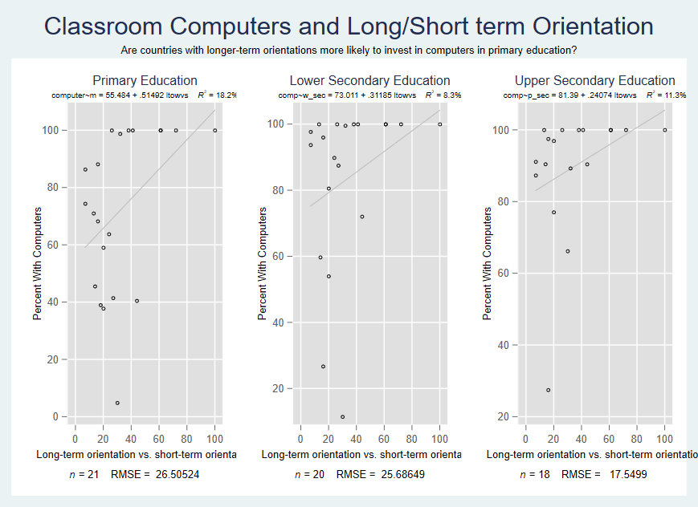

Appendix J

|  |  |  |
| --- | --- | --- |
|  | econ_parity_numeracy | econ_parity_literacy |
| Power Distance | 0.00 | 0.00 |
|  | (0.00) | (0.00) |
| IA- Income | 0.09 | 0.09 |
|  | (0.11) | (0.04)* |
| _cons | 0.87 | 0.89 |
|  | (0.09)** | (0.03)** |
| *R*2 | 0.04 | 0.21 |
| *N* | 22 | 24 |

1. The regression output generated by the plot here is slightly off in that it accounts for all years of data, which inflates the number of data points by 24; however, in a regression for just 2014 data, the coefficient estimates and standard errors are roughly the same, the p value remains < 0.000, and the variance explained is 0.2755.